**Attachmate Tips**

1.Font adjustment and login : **L NMMAIT M4G**

2. **L TSOA** logon to TSO mainframes

3. Sample dataset for compile codes -**SDAF.AF650M00.TESTBIT**

4. Logging and **Browsing DB2 tables**

Go to **START FAD**(Fileaid/DB2)

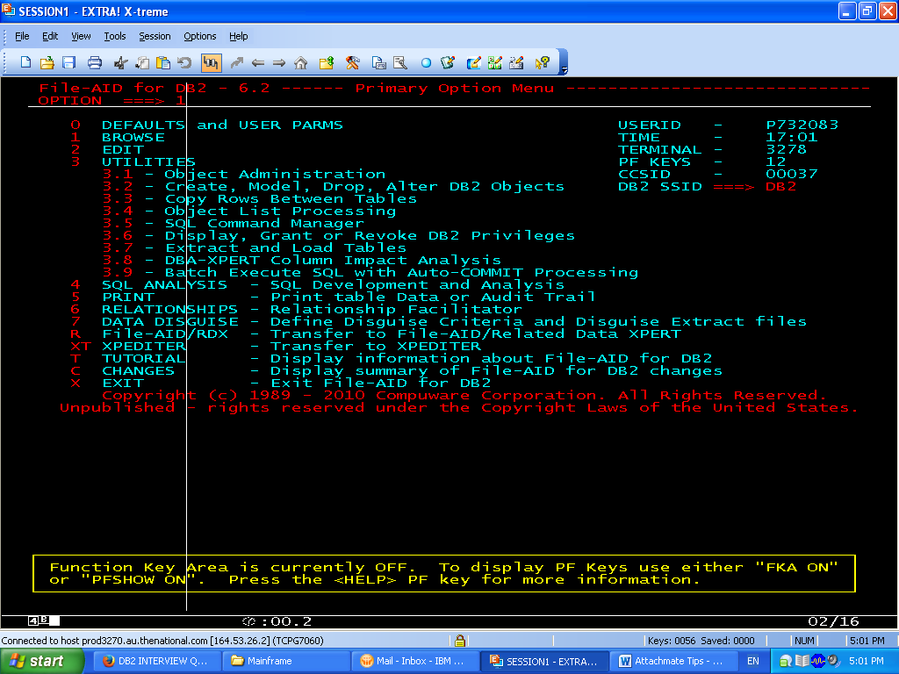

Give

**Creator ===> PD**

**Table Name ===> \***

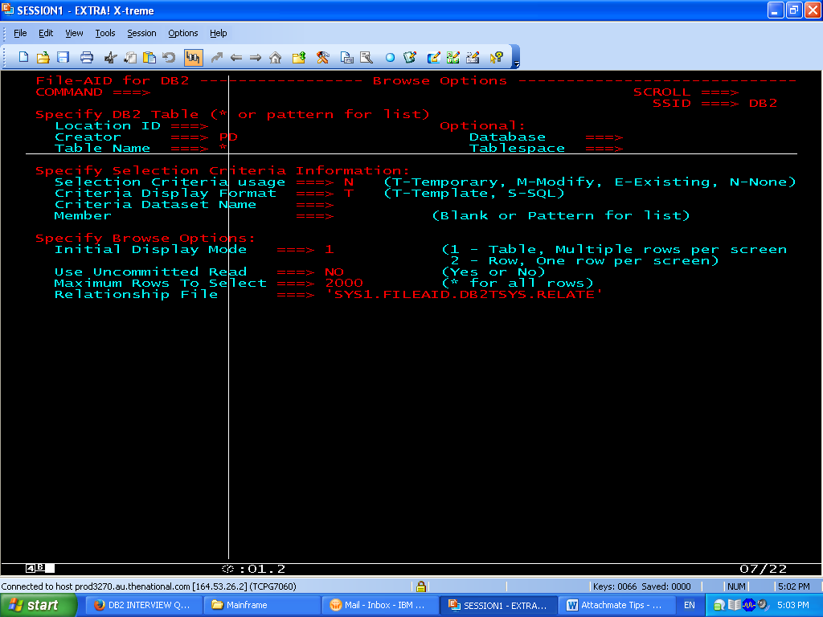

**5. Keyboard settings for Attachmate**

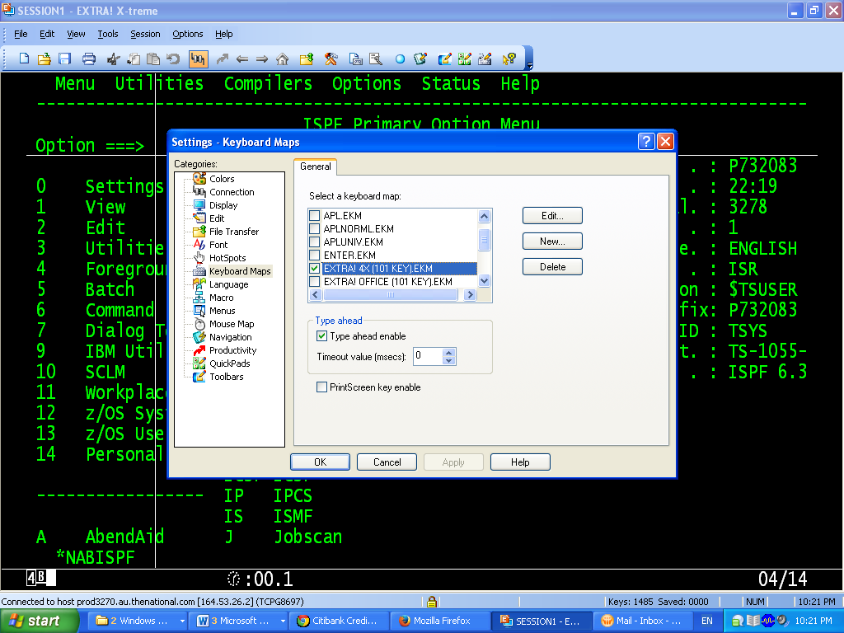

**6.Errors**

**Logoff:**

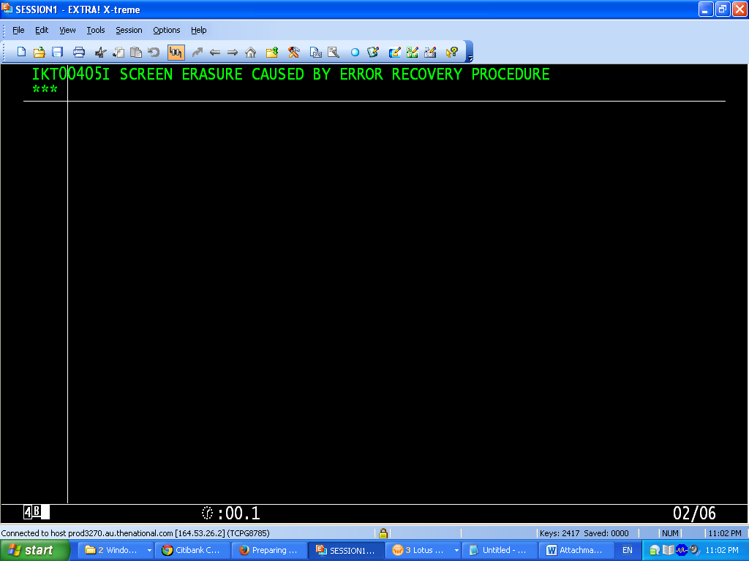

**7.backup**

Press **bkup** after opening the dataset then new member is created in the same library with

**extension O**

**Eg:** AF000M00 member is backed as AF000M0O

8. **DUP**

To duplicate a pds/ps press **dup** before the dataset and enter destination dataset

EG:

source: PROG.DEV8.SPEC.LIBRARY

Dest: SDAF.PP40223.SPEC.LIBRARY

9. To know who got eh dataset please type **WHOHAS** before the dataset it is similar to TSO whosgot